Jesus the servant and Saviour
Reading: from John 13:1-17
Jesus and the disciples were having their evening meal. Jesus got up from the meal and took off his outer clothes. He wrapped a towel round his waist. After that, he poured water into a large bowl. Then he began to wash his disciples’ feet. He dried them with the towel that was wrapped around him.
He came to Simon Peter. “Lord,” Peter said to him, “are you going to wash my feet?”
Jesus replied, “You don’t realise now what I am doing. But later you will understand.”
“No,” said Peter, “you will never wash my feet.”
Jesus answered, “Unless I wash you, you can’t share life with me.”
“Lord,” Simon Peter replied, “not just my feet! Wash my hands and my head too!”
Jesus answered, “People who have had a bath need to wash only their feet. The rest of their body is clean. And you are clean.”
When Jesus finished washing their feet, he put on his clothes. “Do you understand what I have done for you?” he asked. “You call me ‘Teacher’ and ‘Lord’. You are right. That is what I am. I, your Lord and Teacher have washed your feet. So you also should wash one another’s feet. I have given you an example. You should do as I have done for you.”
Thought about the reading
Have you seen King Charles on the TV? He is a very important person. When he meets someone, they bow or curtsey to him because he is so important. Jesus is King of Kings. He is far more important than King Charles. But instead of telling his friends to bow down to him, he washed their feet! He was doing the job of a servant. He was showing them how much he loved them.
He told his disciples that whoever wanted to be a leader, must serve others like a servant. He showed us how to do this by the way he lived, and by dying for us. We must learn to love others the way that Jesus loves us.
Can you think of ways you could serve others? Here are a few ideas; welcoming people, making a cup of tea, helping with the washing up. Maybe you have other ideas. If you ask Jesus, he will help you know what to do.
Prayer
Dear Jesus, thank you that although you are King of kings, you washed the feet of your friends to show how much you loved them.
Please help us to love each other like you love us. Please help us to find ways to serve one another like you served your friends. Amen

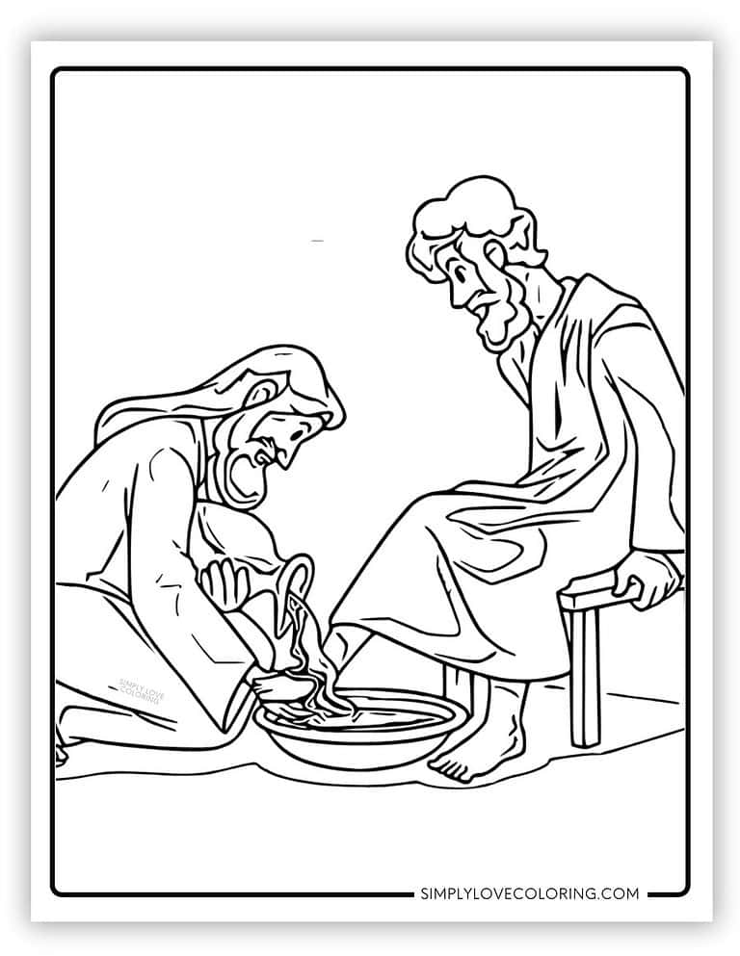

Cambridge Causeway

Autumn 2025
Bible Study notes

Jesus the Reason
4. Jesus servant and Saviour
By Chrissy Cole

